Web programming

Week 10

23BCE5142

Harini S

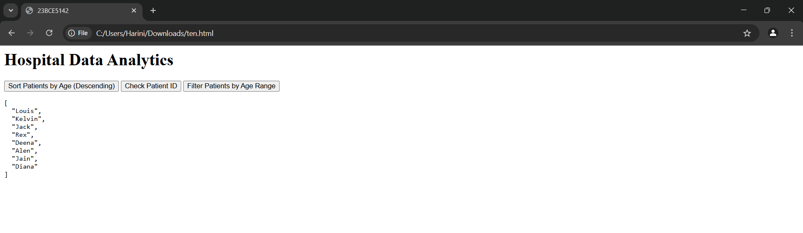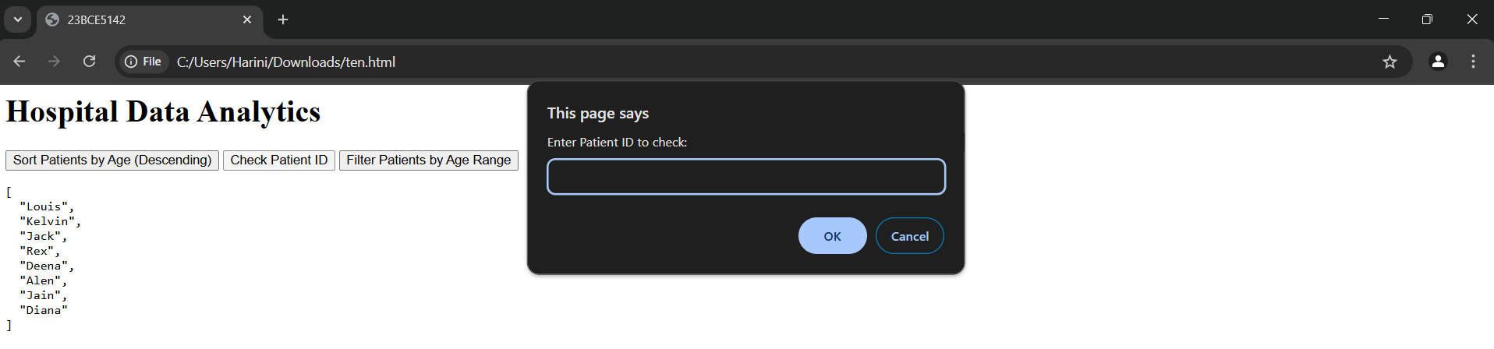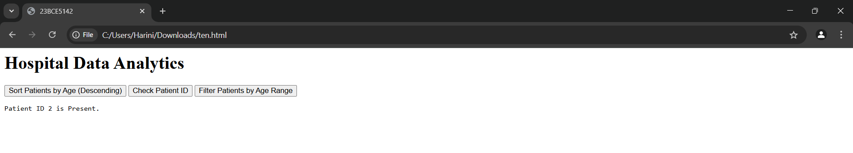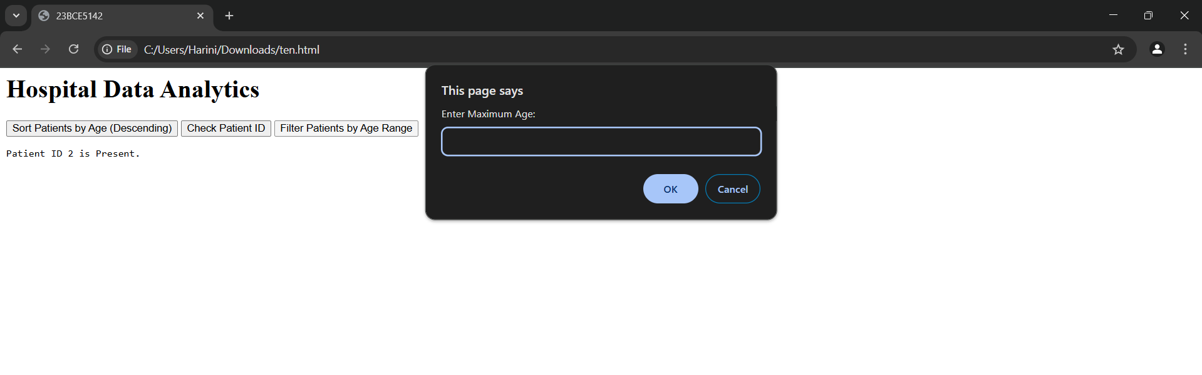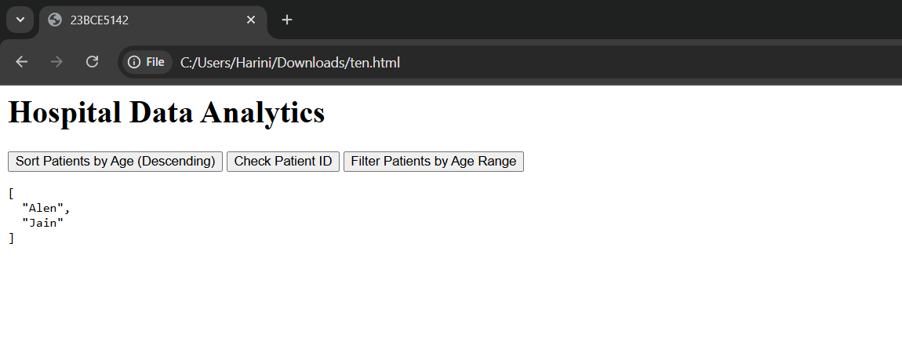<html>

<head>

    <title>23BCE5142</title>

</head>

<body>

    <h1>Hospital Data Analytics</h1>

    <button onclick="displaySortedPatients()">Sort Patients by Age (Descending)</button>

    <button onclick="checkPatientId()">Check Patient ID</button>

    <button onclick="filterPatientsByAgeRange()">Filter Patients by Age Range</button>

    <pre id="output"></pre>

    <script>

        const patients = [

            { PId: 1, Name: "Alen", Age: 39 },

            { PId: 2, Name: "Deena", Age: 47 },

            { PId: 3, Name: "Diana", Age: 21 },

            { PId: 4, Name: "Jack", Age: 54 },

            { PId: 5, Name: "Jain", Age: 23 },

            { PId: 6, Name: "Kelvin", Age: 61 },

            { PId: 7, Name: "Louis", Age: 69 },

            { PId: 8, Name: "Rex", Age: 49 }

        ];

        function sortPatientsByAgeDescending(patients) {

            return patients.sort((a, b) => b.Age - a.Age).map(patient => patient.Name);

        }

        function displaySortedPatients() {

            document.getElementById("output").textContent = JSON.stringify(sortPatientsByAgeDescending([...patients]), null, 2);

        }

        // (ii) Check if a P-Id exists in the list

        function isPatientIdPresent(patients, PId) {

            return patients.some(patient => patient.PId === PId);

        }

        function checkPatientId() {

            let id = prompt("Enter Patient ID to check:");

            let result = isPatientIdPresent(patients, parseInt(id)) ? "Present" : "Not Present";

            document.getElementById("output").textContent = `Patient ID ${id} is ${result}.`;

        }

        // (iii) Filter patients by age range

        function filterPatientsByAge(patients, minAge, maxAge) {

            return patients.filter(patient => patient.Age >= minAge && patient.Age <= maxAge).map(patient => patient.Name);

        }

        function filterPatientsByAgeRange() {

            let minAge = prompt("Enter Minimum Age:");

            let maxAge = prompt("Enter Maximum Age:");

            let filtered = filterPatientsByAge(patients, parseInt(minAge), parseInt(maxAge));

            document.getElementById("output").textContent = JSON.stringify(filtered, null, 2);

        }

    </script>

</body>

</html>

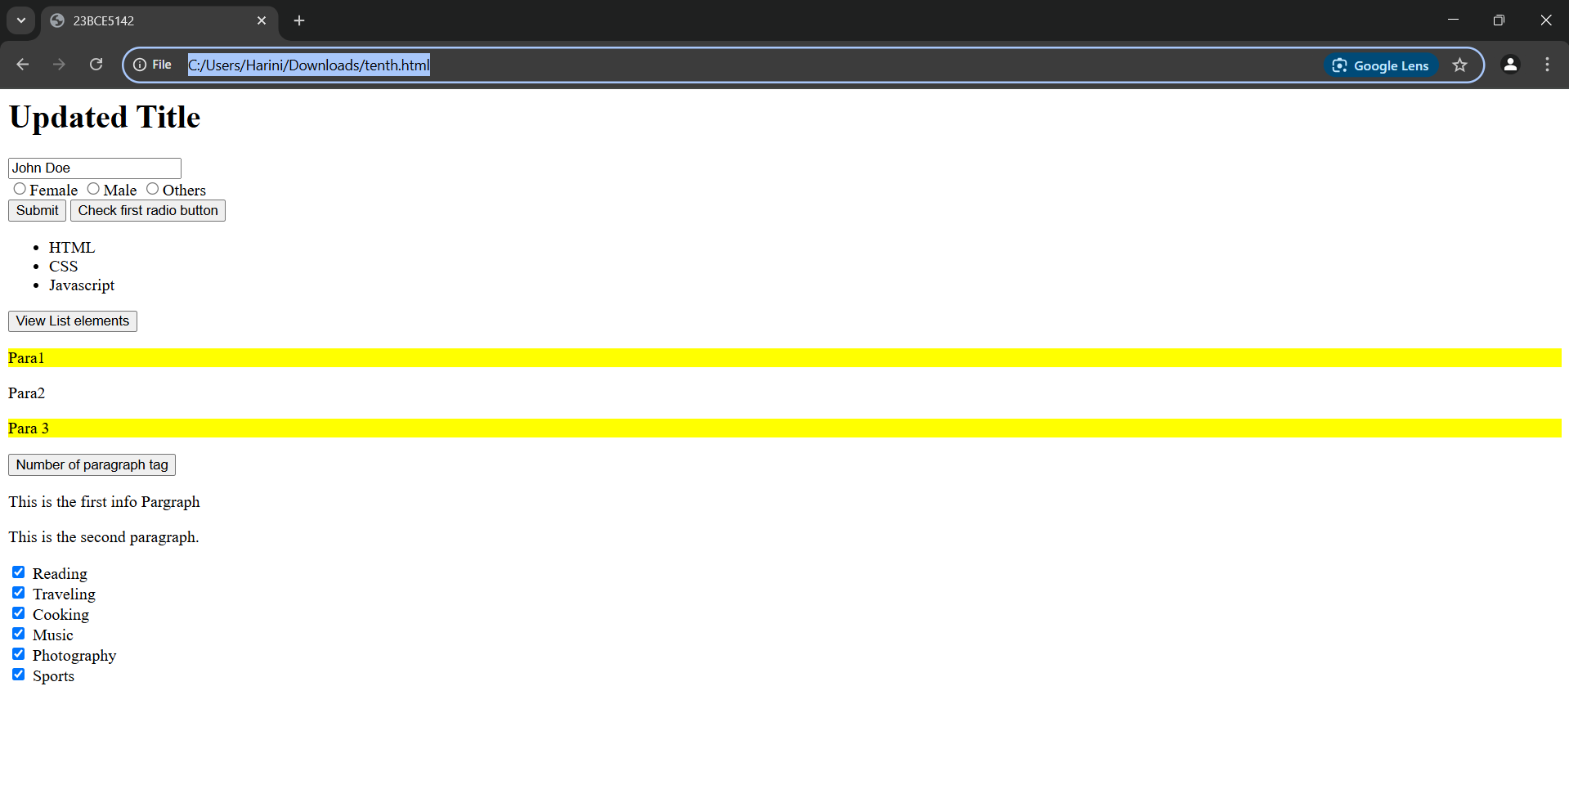

<html>

<head>

    <title>23BCE5142</title>

</head>

<body>

    <h1 id="heading">Title</h1>

    <input type="text" value="Name" name="username">

    <br>

    <input type="radio" name="gender" value="Female">Female

    <input type="radio" name="gender" value="Male">Male

    <input type="radio" name="gender" value="others">Others

    <br>

    <button type="button" onclick="displayRadioValue()">Submit</button>

    <button type="button" onclick="checkFirstRadio()">Check first radio button</button>

    <br>

    <div id="result"></div>

    <ul>

        <li>HTML</li>

        <li>CSS</li>

        <li>Javascript</li>

    </ul>

    <button type="button" onclick="disp()">View List elements</button>

    <div id="res2"></div>

    <p class="input-field" style="background-color: antiquewhite;">Para1</p>

    <p>Para2</p>

    <p class="input-field" style="background-color: beige;">Para 3</p>

    <button type="button" onclick="para()">Number of paragraph tag</button>

    <div id="res3"></div>

    <p class="info">This is the first paragraph.</p>

    <p class="info">This is the second paragraph.</p>

    <input type="checkbox" class="hobby" value="Reading"> Reading<br>

    <input type="checkbox" class="hobby" value="Traveling"> Traveling<br>

    <input type="checkbox" class="hobby" value="Cooking"> Cooking<br>

    <input type="checkbox" class="hobby" value="Music"> Music<br>

    <input type="checkbox" class="hobby" value="Photography"> Photography<br>

    <input type="checkbox" class="hobby" value="Sports"> Sports<br>

    <script>

        document.getElementById("heading").innerHTML = "Updated Title";

        document.getElementsByName("username")[0].value = "John Doe";

        var inputFields = document.getElementsByClassName("input-field");

        for (var i = 0; i < inputFields.length; i++) {

            inputFields[i].style.backgroundColor = "yellow";

        }

        var ele1 = document.getElementsByName("gender");

        document.querySelector(".info").innerHTML = "This is the first info Pargraph";

        function displayRadioValue() {

            var ele = document.getElementsByName('gender');

            for (i = 0; i < ele.length; i++) {

                if (ele[i].checked)

                    document.getElementById("result").innerHTML = "Gender: " + ele[i].value;

            }

        }

        function disp() {

            var x = document.getElementsByTagName("li");

            var content = [];

            for (i = 0; i < x.length; i++) {

                content.push(x[i].innerHTML);

            }

            console.log(content);

        }

        function para() {

            var pc = document.getElementsByTagName("p");

            var cnt = 0;

            for (i = 0; i < pc.length; i++) {

                cnt++;

            }

            document.getElementById("res3").innerHTML = cnt;

        }

        function checkFirstRadio() {

            document.querySelector('input[name="gender"]').checked = true;

        }

        let infoParagraphs = document.querySelectorAll('p.info');

        infoParagraphs.forEach(function (p) {

            console.log(p.textContent);

        });

        let hobbyCheckboxes = document.querySelectorAll('input[type="checkbox"].hobby');

        hobbyCheckboxes.forEach(function (checkbox) {

            checkbox.checked = true;

            if (checkbox.checked) {

                console.log(checkbox.value);

            }

        });

    </script>

</body>

</html>

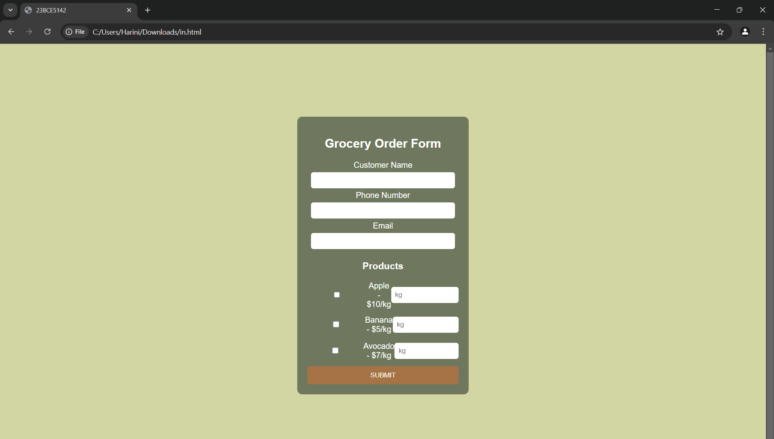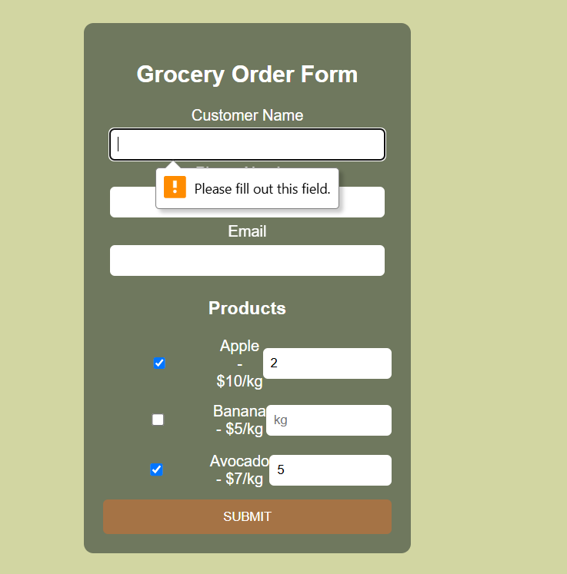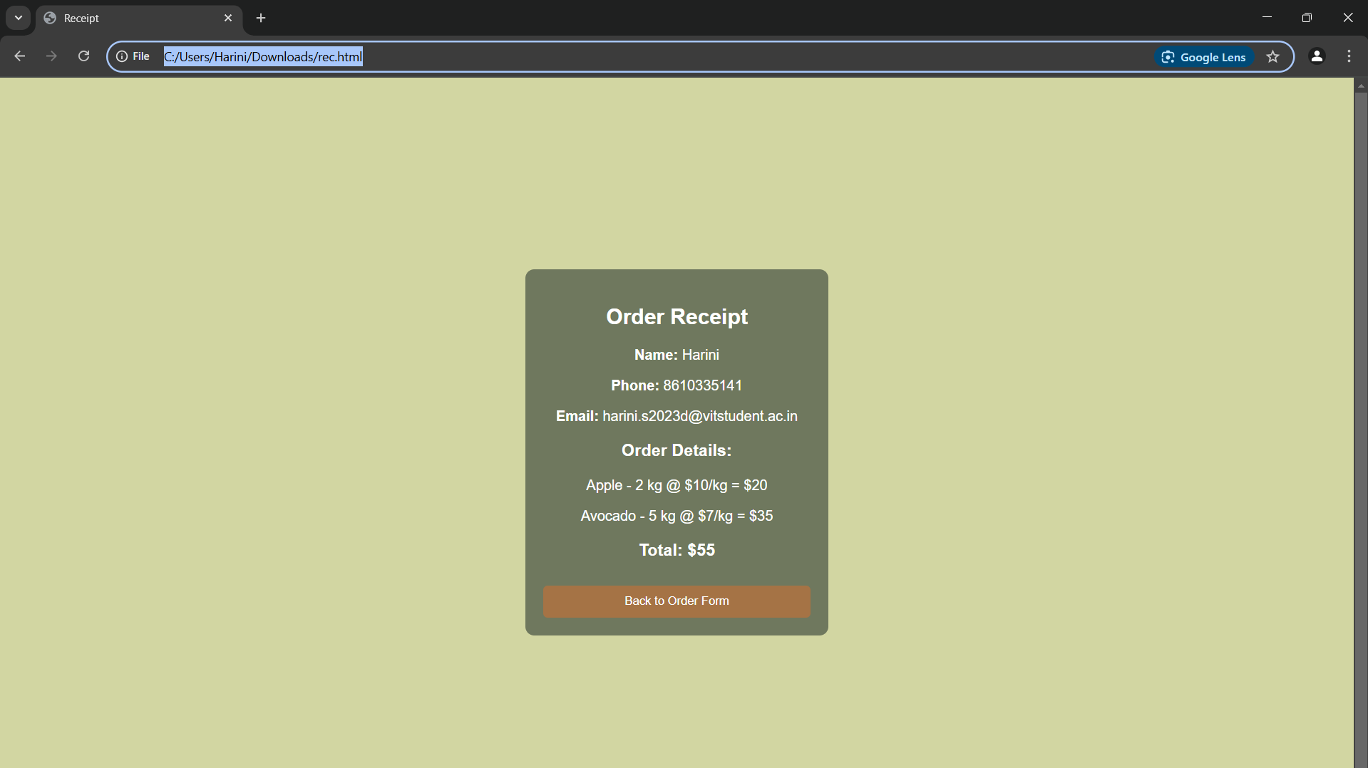<!DOCTYPE html>

<html>

<head>

    <title>23BCE5142</title>

    <link rel="stylesheet" href="st.css">

</head>

<body>

    <div class="container">

        <h2>Grocery Order Form</h2>

        <form id="orderForm">

            <label>Customer Name</label>

            <input type="text" id="name" required><br>

            <label>Phone Number</label>

            <input type="tel" id="phone" required><br>

            <label>Email</label>

            <input type="email" id="email" required><br>

            <h3>Products</h3>

            <div class="product">

                <input type="checkbox" id="apple">

                <label for="apple">Apple - $10/kg</label>

                <input type="number" id="appleQty" min="0" placeholder="kg">

            </div>

            <div class="product">

                <input type="checkbox" id="banana">

                <label for="banana">Banana - $5/kg</label>

                <input type="number" id="bananaQty" min="0" placeholder="kg">

            </div>

            <div class="product">

                <input type="checkbox" id="avocado">

                <label for="avocado">Avocado - $7/kg</label>

                <input type="number" id="avocadoQty" min="0" placeholder="kg">

            </div>

            <button type="submit">SUBMIT</button>

        </form>

    </div>

    <script src="scr.js"></script>

</body>

</html>

document.getElementById("orderForm").addEventListener("submit", function(event) {

    event.preventDefault();

    let name = document.getElementById("name").value;

    let phone = document.getElementById("phone").value;

    let email = document.getElementById("email").value;

    let order = [];

    if (document.getElementById("apple").checked) {

        let qty = document.getElementById("appleQty").value || 0;

        order.push({ item: "Apple", price: 10, quantity: qty });

    }

    if (document.getElementById("banana").checked) {

        let qty = document.getElementById("bananaQty").value || 0;

        order.push({ item: "Banana", price: 5, quantity: qty });

    }

    if (document.getElementById("avocado").checked) {

        let qty = document.getElementById("avocadoQty").value || 0;

        order.push({ item: "Avocado", price: 7, quantity: qty });

    }

    let orderData = {

        name: name,

        phone: phone,

        email: email,

        order: order

    };

    localStorage.setItem("orderData", JSON.stringify(orderData));

    window.location.href = "rec.html";

});

<html>

<head>

    <title>Receipt</title>

    <link rel="stylesheet" href="st.css">

</head>

<body>

    <div class="container">

        <h2>Order Receipt</h2>

        <div id="receipt"></div>

        <button onclick="window.location.href='in.html'">Back to Order Form</button>

    </div>

    <script>

        let orderData = JSON.parse(localStorage.getItem("orderData"));

        let receiptDiv = document.getElementById("receipt");

        if (orderData) {

            let totalAmount = 0;

            let receiptHTML = `<p><strong>Name:</strong> ${orderData.name}</p>

                               <p><strong>Phone:</strong> ${orderData.phone}</p>

                               <p><strong>Email:</strong> ${orderData.email}</p>

                               <h3>Order Details:</h3>`;

            orderData.order.forEach(item => {

                let cost = item.price \* item.quantity;

                totalAmount += cost;

                receiptHTML += `<p>${item.item} - ${item.quantity} kg @ $${item.price}/kg = $${cost}</p>`;

            });

            receiptHTML += `<h3>Total: $${totalAmount}</h3>`;

            receiptDiv.innerHTML = receiptHTML;

        } else {

            receiptDiv.innerHTML = "<p>No order data found!</p>";

        }

    </script>

</body>

</html>

body {

    font-family: Arial;

    background-color: #d2d6a2;

    display: flex;

    justify-content: center;

    align-items: center;

    height: 100vh;

}

.container {

    background-color: #6f785e;

    padding: 20px;

    border-radius: 10px;

    color: white;

    width: 300px;

    text-align: center;

}

input {

    width: 90%;

    padding: 8px;

    margin: 5px 0;

    border: none;

    border-radius: 5px;

}

.product {

    display: flex;

    justify-content: space-between;

    align-items: center;

    margin-top: 10px;

}

button {

    background-color: #a57345;

    color: white;

    padding: 10px;

    border: none;

    width: 100%;

    border-radius: 5px;

    margin-top: 10px;

}

button:hover {

    background-color: #8b5a2b;

}